Too much information? The role of an evidence pyramid in deciding which publications to look at first

Arghh! Having searched for information on a particular health question you will often find that you are overloaded with information. What should you look at first?
This is where an evidence pyramid can come in handy. This illustrates the different study types in ascending order, based on the quality and reliability of each study design.

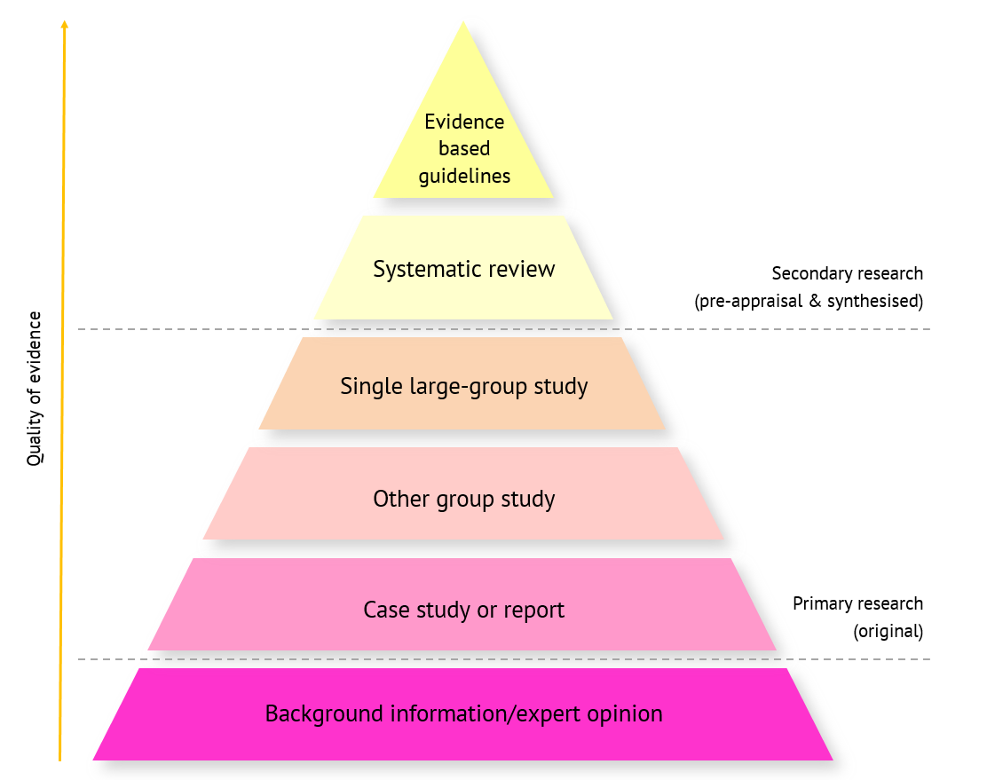

Working from the top down:
- The most reliable and current evidence (‘best evidence’) for a particular question will be found in evidence-based guidelines which are developed by an expert group based on the evidence contained in a full systematic review of all relevant research evidence.
- If there is no current evidence-based guidance for your question, look for systematic reviews which are critical syntheses of all the reliable individual (primary) studies on the topic.
- In the absence of systematic review(s), or to bring an existing systematic review up to date with more recent studies, you will be looking for individual studies.
- Look at the studies that include the largest numbers of individuals first since, when well designed to minimise any potential for bias, these will have the most reliable findings.
- If there are no group studies you will need to rely on case studies or reports of individual subjects, or a series of these. Being small, they cannot be controlled to minimise the potential for bias
- Lastly but not least, background information or expert opinion has its place in the evidence pyramid but it can be heavily influenced by beliefs, opinions and politics.

If you need to look at individual studies, the best type of study will depend on the type of question you are asking:
- If you are looking at prevention or treatment – e.g. life style changes to reduce heart disease or specific treatments to reduce sickness in pregnancy - you will be looking for intervention studies such as a trial of one treatment compared to another.
- If you are looking at the risk factors associated with developing a particular health problem – e.g. dehydration leading to reduced brain function or smoking related to lung cancer - you will be looking for observational studies where no intervention is given but the issue of interest is measured in a group of people who are then followed through in time to see if this effects a particular outcome.

